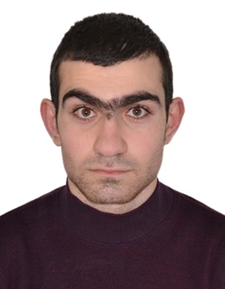 **Gurgen Grigoryan**

8a Arzumanyan str., Yerevan 0038, Armenia

+374 (93)-089-609 | [gurgen.grigoryan484@gmail.com](mailto:gurgen.grigoryan484@gmail.com)

# EXPERIENCE

Synopsys

A&MS Circuit Design Engr, I Mar. 2021 – present

Analog/Mixed-signal I/O circuit design and optimization

Support necessary simulations for customers

Intern (Technical-Engineering) Dec. 2020 – Mar. 2021

Schematic design and optimization of digital schemes

# Education

**Master of Electrical Engineering**

National Polytechnic University of Armenia 2021 -2023

**Field of Study:**

VLSI, Synopsys Armenia 2021 - 2023

Diploma with honors

**Bachelor of Electrical Engineering**

National Polytechnic University of Armenia 2017-2021

**Field of Study:**

Electronics, faculty of Cybernetics 2017-2019

VLSI, Synopsys Armenia 2019-2021

Diploma with honors

# Additional Information

**Tools**

* Custom compiler
* Design compiler (basic)
* IC Compiler (basic)
* HSPICE
* FineSim
* VCS
* Verilog
* SiliconSmart
* PrimeTime (basic)

**Computer Skills**

* MS Office (Word, Excel, Power Point)
* C++(basic)
* Python (basic)
* Linux (basic)

**Languages**

Armenian, Russian, English.